

PICKLEBALL COURT RESERVATION MANAGEMENT SYSTEM
Final Release Document

– Da Nang, March 2025 –
Table of Contents
I. Deliverable Package 3
II. Installation Guides 3
III. User Manual 4
1. Overview 4
2. User Manual Guide for Guest 4
3. User Manual Guide for User 7
4 . User Manual Guide for Admin 17

I. Deliverable Package

No. | File | Notes
1 | Group2_DB_final.sql | Database, including both table structures and table data
2 | Group2_SRS_final.docx | Final SRS (Requirement) Document
3 | Group2_SDS_final.docx | Final SDS (Design) Document
4 | Group2_Final Product Backlog.xlsx | Final status for the application functions, which include:  - Function name, feature, roles, function description (changes compared to the original requirements are highlighted)  - In Charge, Planned iteration & Actual iteration  - Final status & note on the update you made  - The links to the SRS & SDS are tracked
5 | Group2_Issues Report.xlsx | Final issues tracking list of the whole project
6 | Group2_Final Release Document.dox | Final Project Report.dox

Other related deliverables:
- Tagged source codes: https://github.com/Chun1503/pickleball48.git
- Demonstration video: <<YouTube link>>

II. Installation Guides
- System Requirements
1.1 . Hardware requirement
- Client: Window and mobile devices with internet access.
- Supported Browsers: Chrome - latest, Firefox - latest, Opera - latest, Edge – 13+, Safari – 9+.
- Server: Minimum 2 Core CPU, 1GB RAM and storage at least 20GB.
1.2 . Software requirement

No. | Name | Version | Description
1 | Web browser | Chrome, Firefox, Microsoft Edge | Using for development
2 | Modelling web | Figma | Using for modelling web
3 | Modelling tool | Draw.io | Software modelling tool
4 | Netbean | Latest | Code Editor
5 | Git | Lastest | Version control

- Installation Instruction
To get a local copy up and running follow these simple example steps.
Installation
Extract and store in drive D:/
Clone the repo
git clone : https://github.com/Chun1503/pickleball48.git
Open project by NetBeans or EclipseC

III. User Manual
[In this part, you provide overall descriptions of the application, the briefs of the application’s workflows and the details guide of each workflow where the end user can use

1. Overview
1. Client: Web browsers with internet access.
2. Supported Browsers: Chrome - latest, Firefox - latest, Opera - latest, Edge – 13+, Safari – 9+.
3. This user guide will explain the usage and steps for each feature in Cinemagic Online Ticket Booking Platform.

2. User Manual Guide for Guest
2.1 View Homepage
This is the function to view Pickleball Website’s Homepage as a guest. Steps to follow:
1: Open project with Netbean
2: System will redirect to Landing page
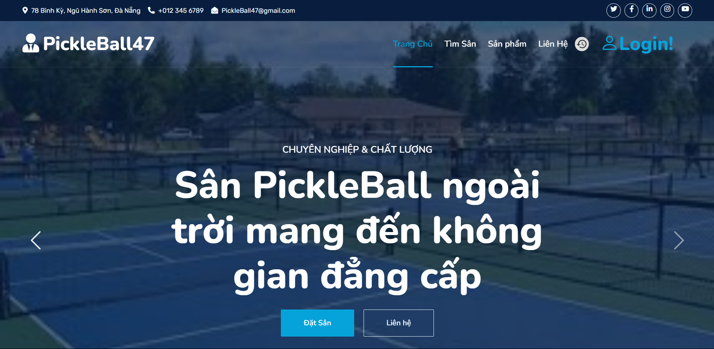

2.2 Sign Up
a. Sign Up for a PickleBall47 Account
This function allows users to sign up for an account on the PickleBall47 website. Steps to follow:
- Open the project with NetBeans.
- Click on the "Login" button in the top right menu.
- Select the "Đăng ký" option 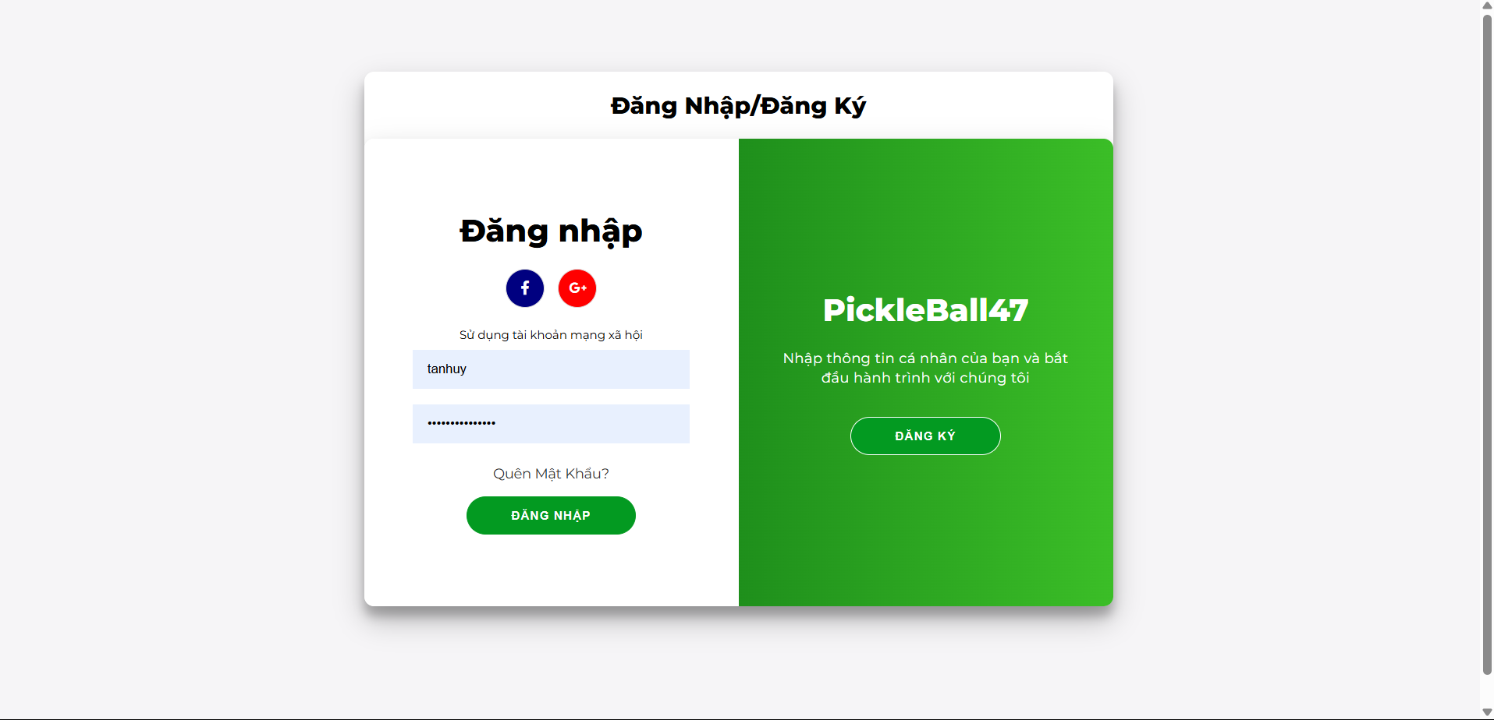
- Type in all the required fields needed to create account
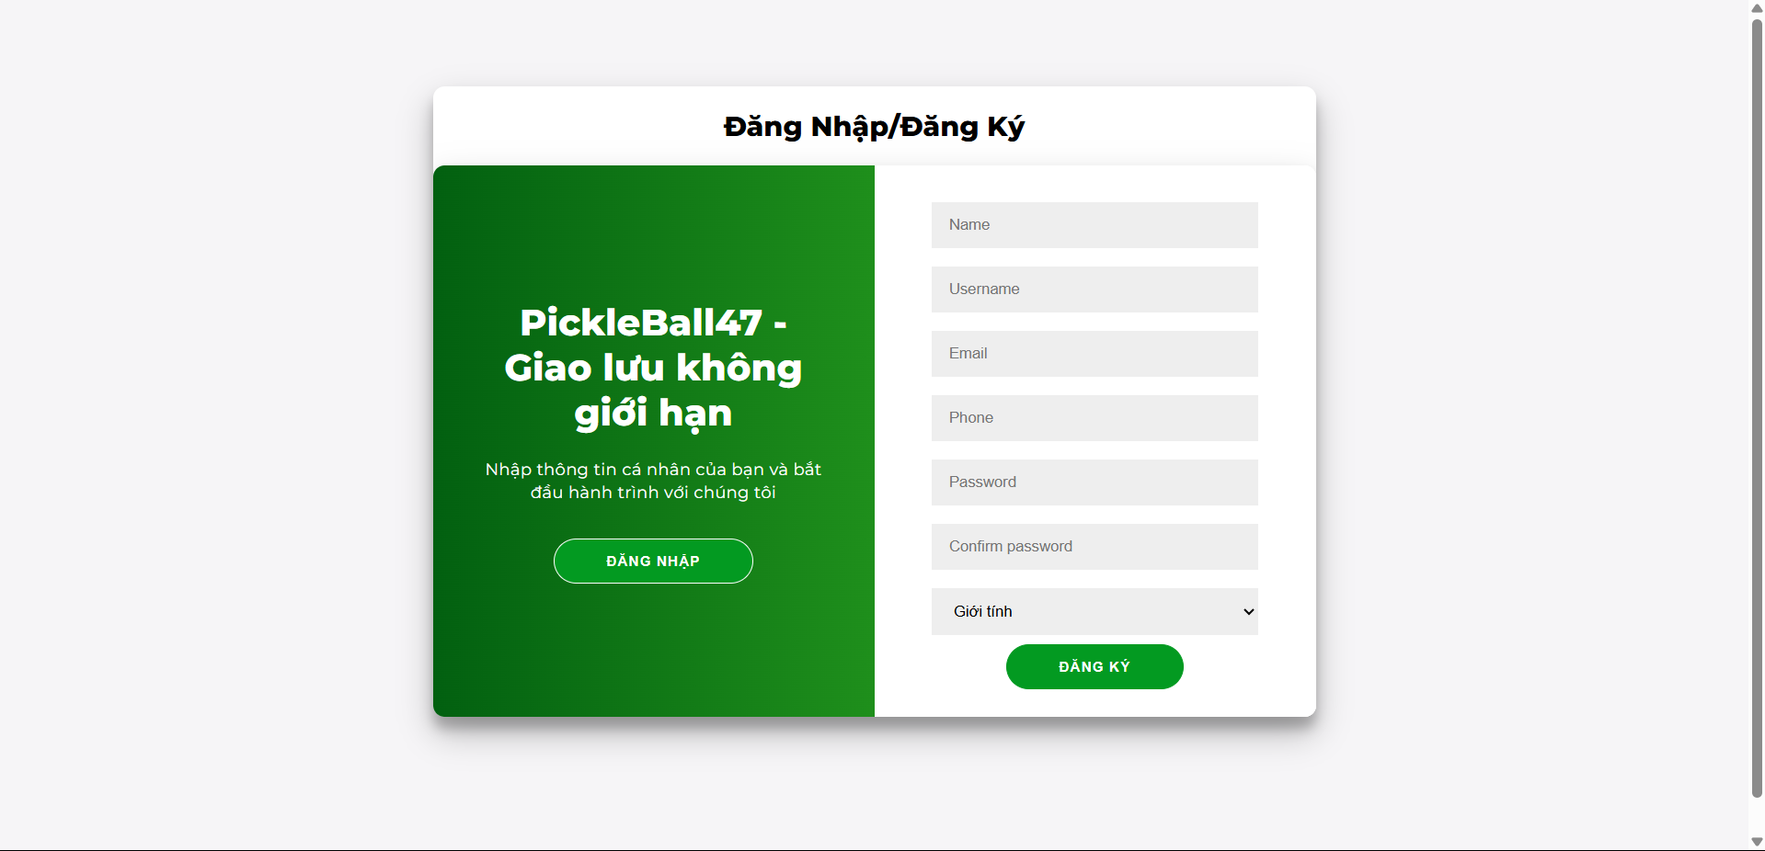
- Click on button 
2.3 View Search Field and View Product Sport
a. View Search Field on Homepage
This function displays the list of available PickleBall courts for booking on the PickleBall47 website homepage. Steps to follow:
- Open the project with NetBeans.
- Click the "Tìm sân" button on the navigation bar to view the available courts.

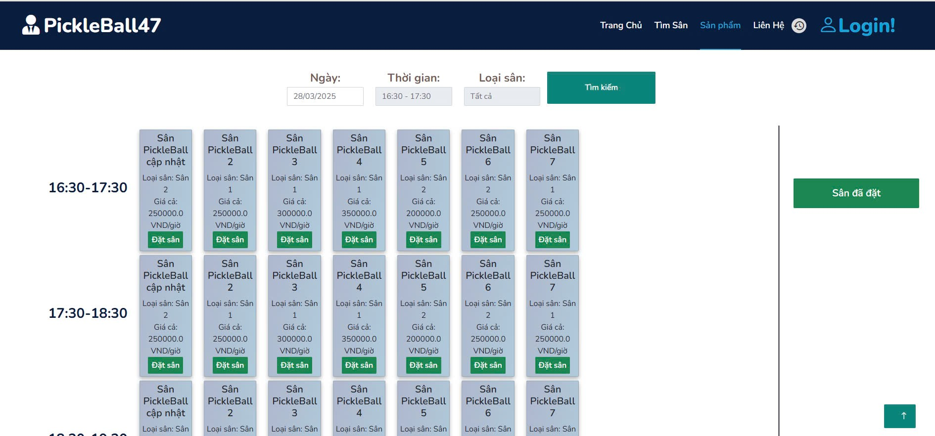
b. View Product Sport
This function displays the list of available PickleBall products for purchase on the PickleBall47 website homepage. Steps to follow:
- Open the project with NetBeans.
- Click the "Sản phẩm" button on the navigation bar to view the product list.
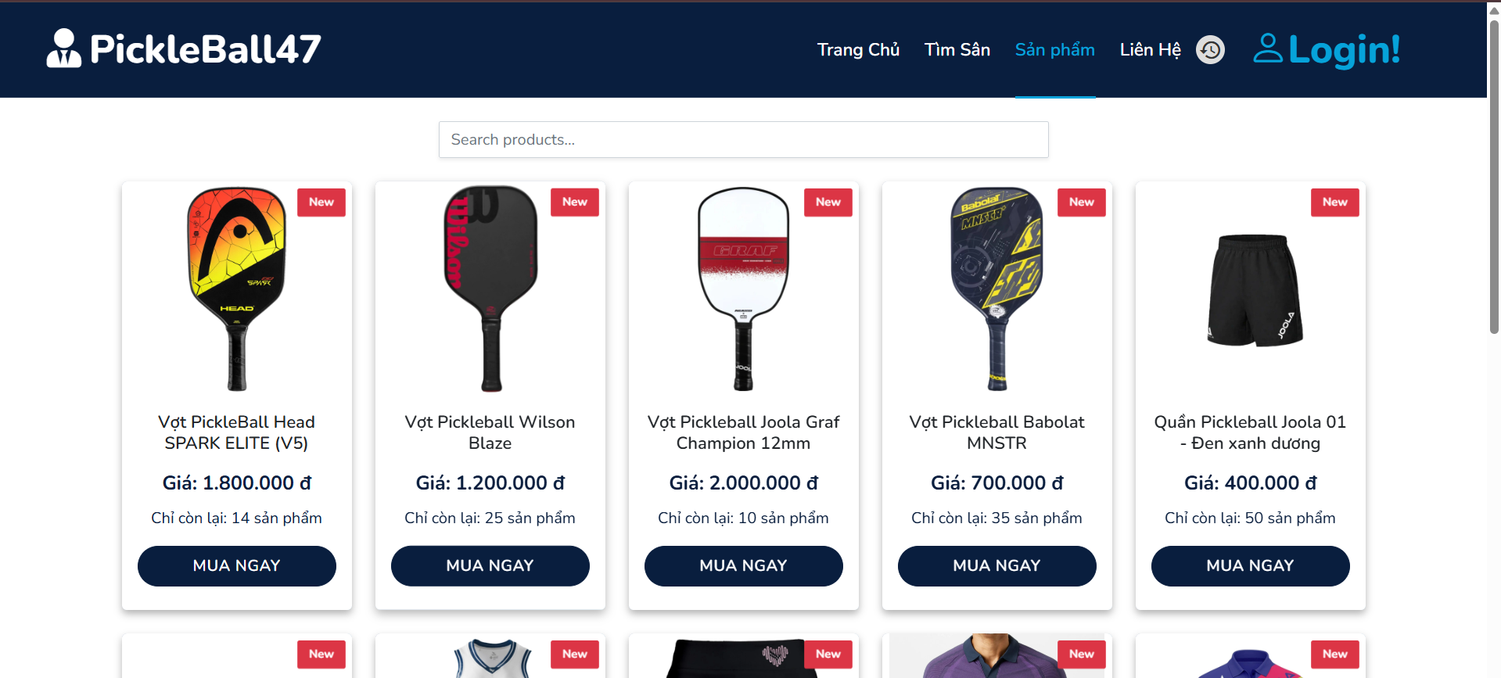

- Click on a product to view its details, including the name, price, description, stock status, and key features.
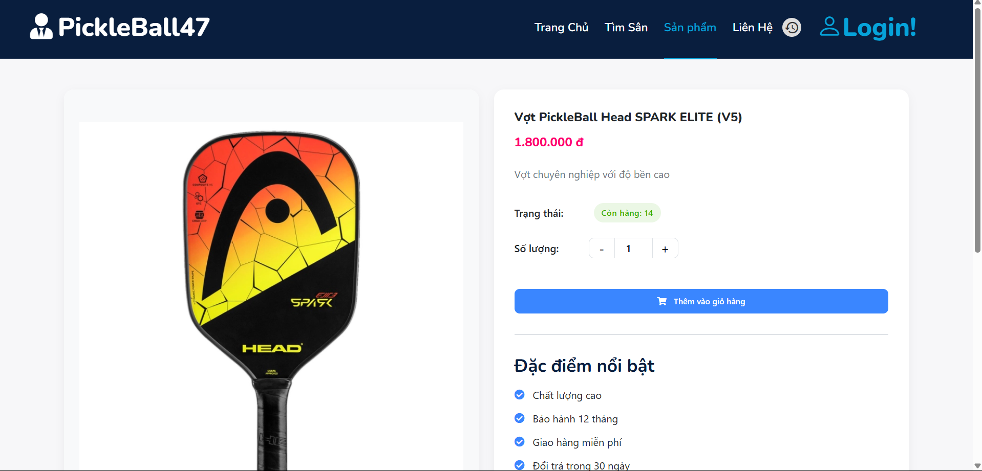
- Adjust the quantity using the "+" or "-" buttons if needed.
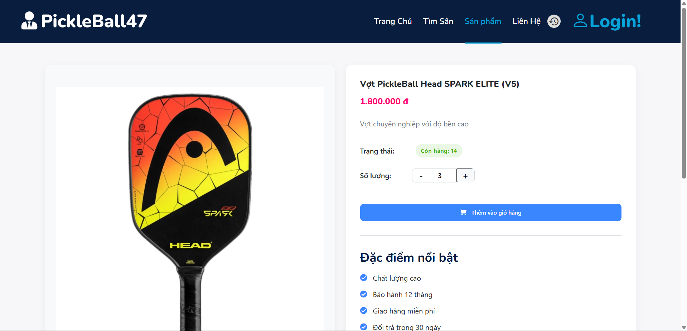
- Click the "Add to Cart" button to add the product to your shopping cart.
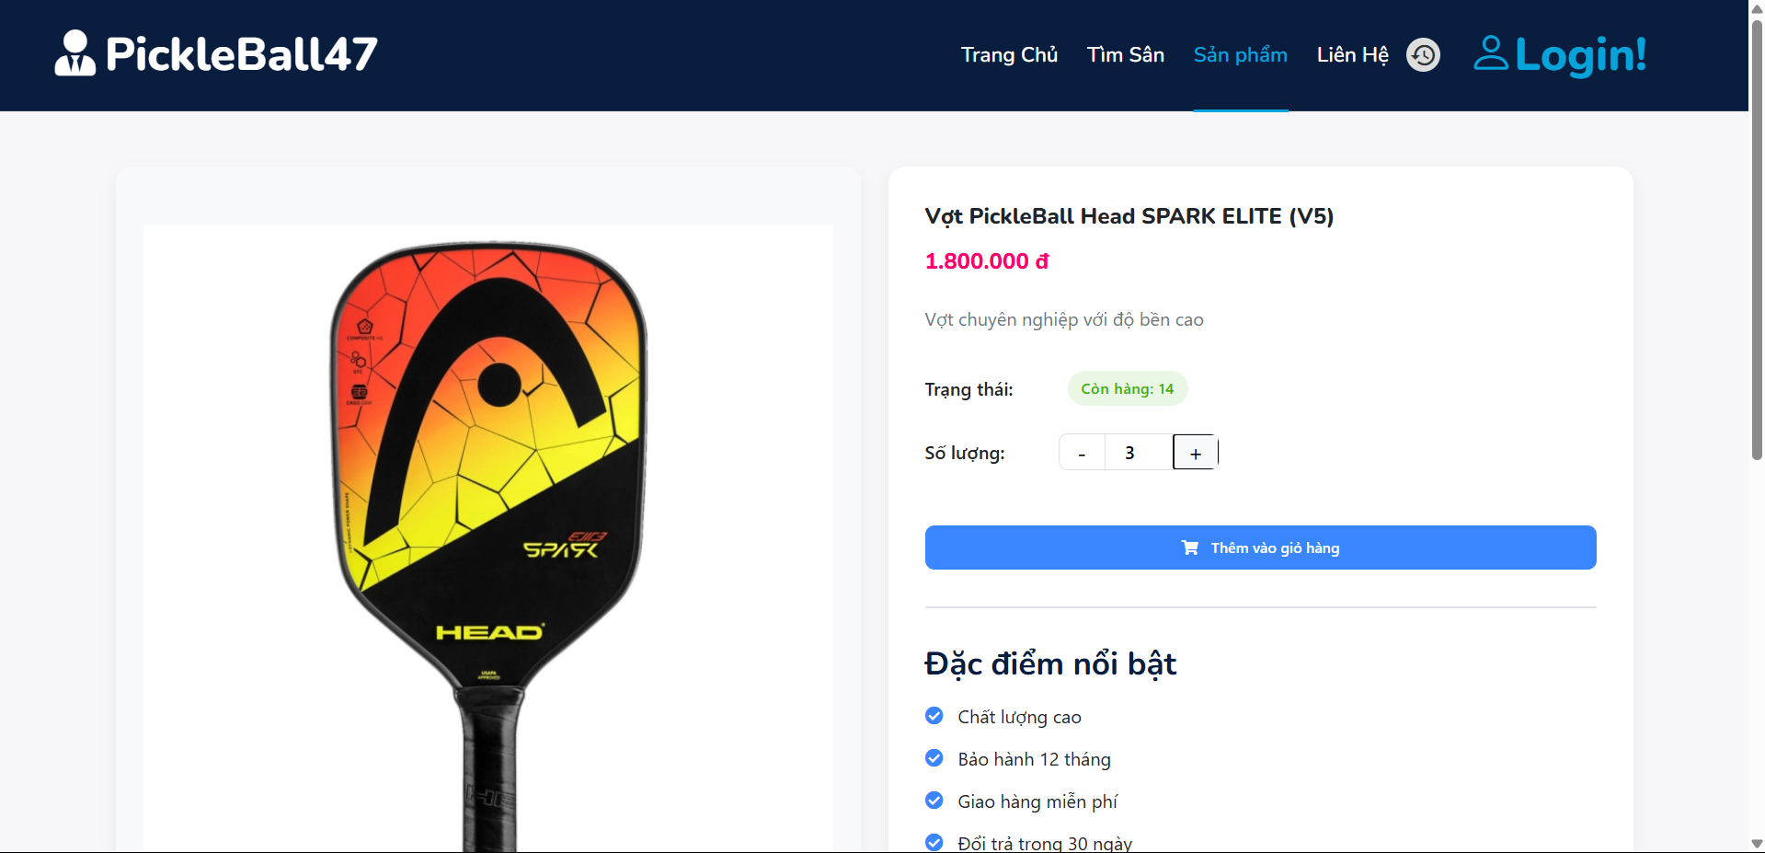
- After clicking "Add to Cart," a login prompt appears, requiring you to sign in before proceeding with the purchase.

User Manual Guide for User
3.1 Sign In, Sign out
- Sign In
This feature allows users to log in to the PickleBall47 platform to book courts and access services. Steps to follow:
  - Visit the PickleBall47 website.
  - Click the "Login!" button in the top right corner.
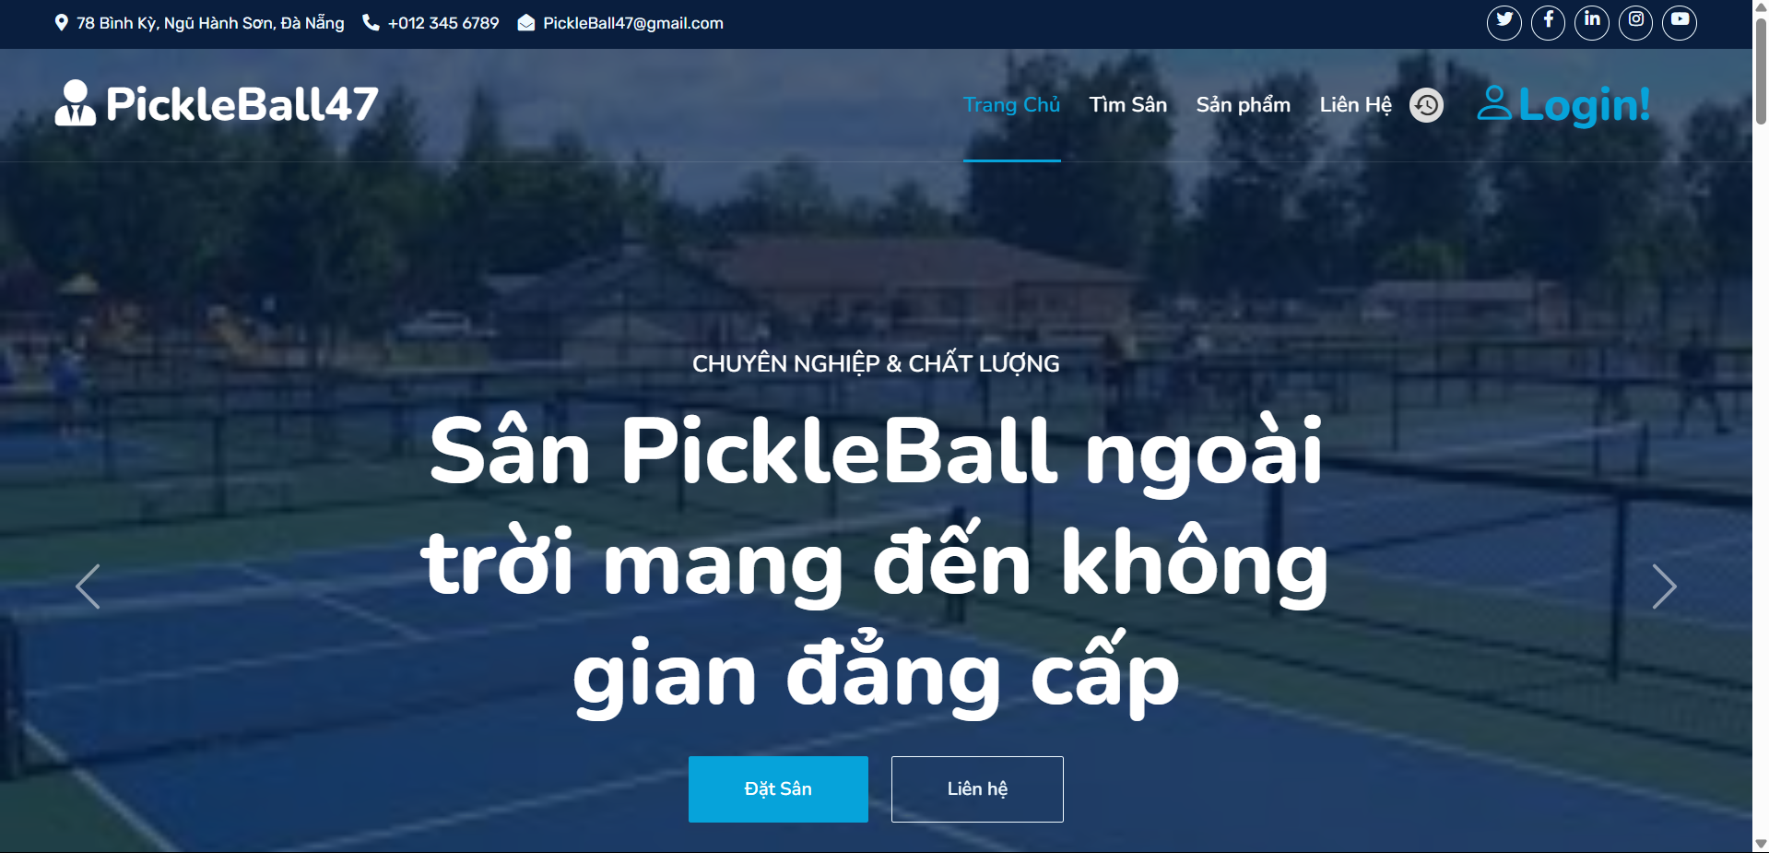
  - The system will redirect to the Login / Register page.
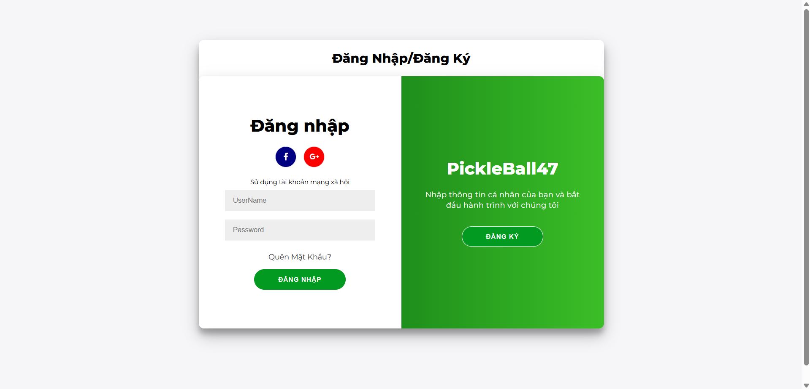
  - Choose a login method:
- Via social media: Click on the Google icons.
- Using a PickleBall47 account: Enter your Username and Password in the respective fields.
  - Click the "Login" button to proceed.
  - If the information is valid, the system will redirect to the homepage.
b. Sign Out
This feature allows users to log out of the PickleBall47 platform and end their login session.
Steps to follow:
- Access the Homepage while logged into your account.
- Hover over your profile avatar in the top right corner.
- Click on "Đăng xuất" (Logout) to end the session.
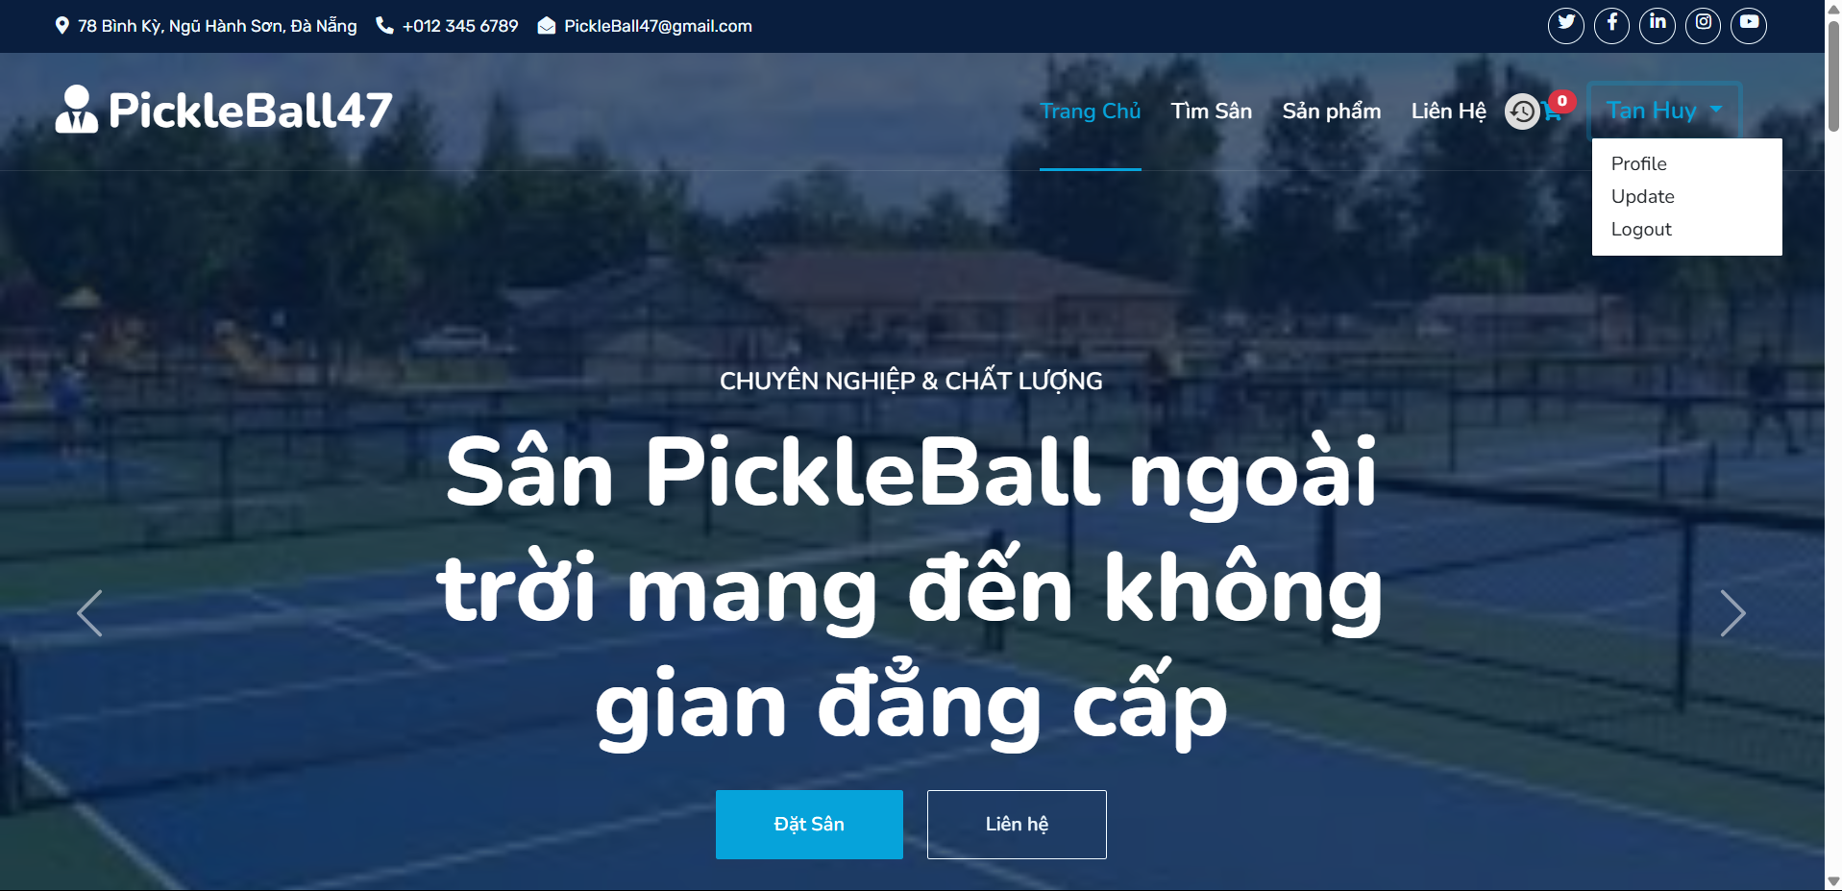

3.2 Update profile
This is a function that allows users to change their information. Steps to follow:
● Step 1:Access the Homepage with an account
● Step 2:Click on “Tài khoản của tôi” button in Homepage

● Step 3:Change the information you want to change and press the "Cập nhật" button
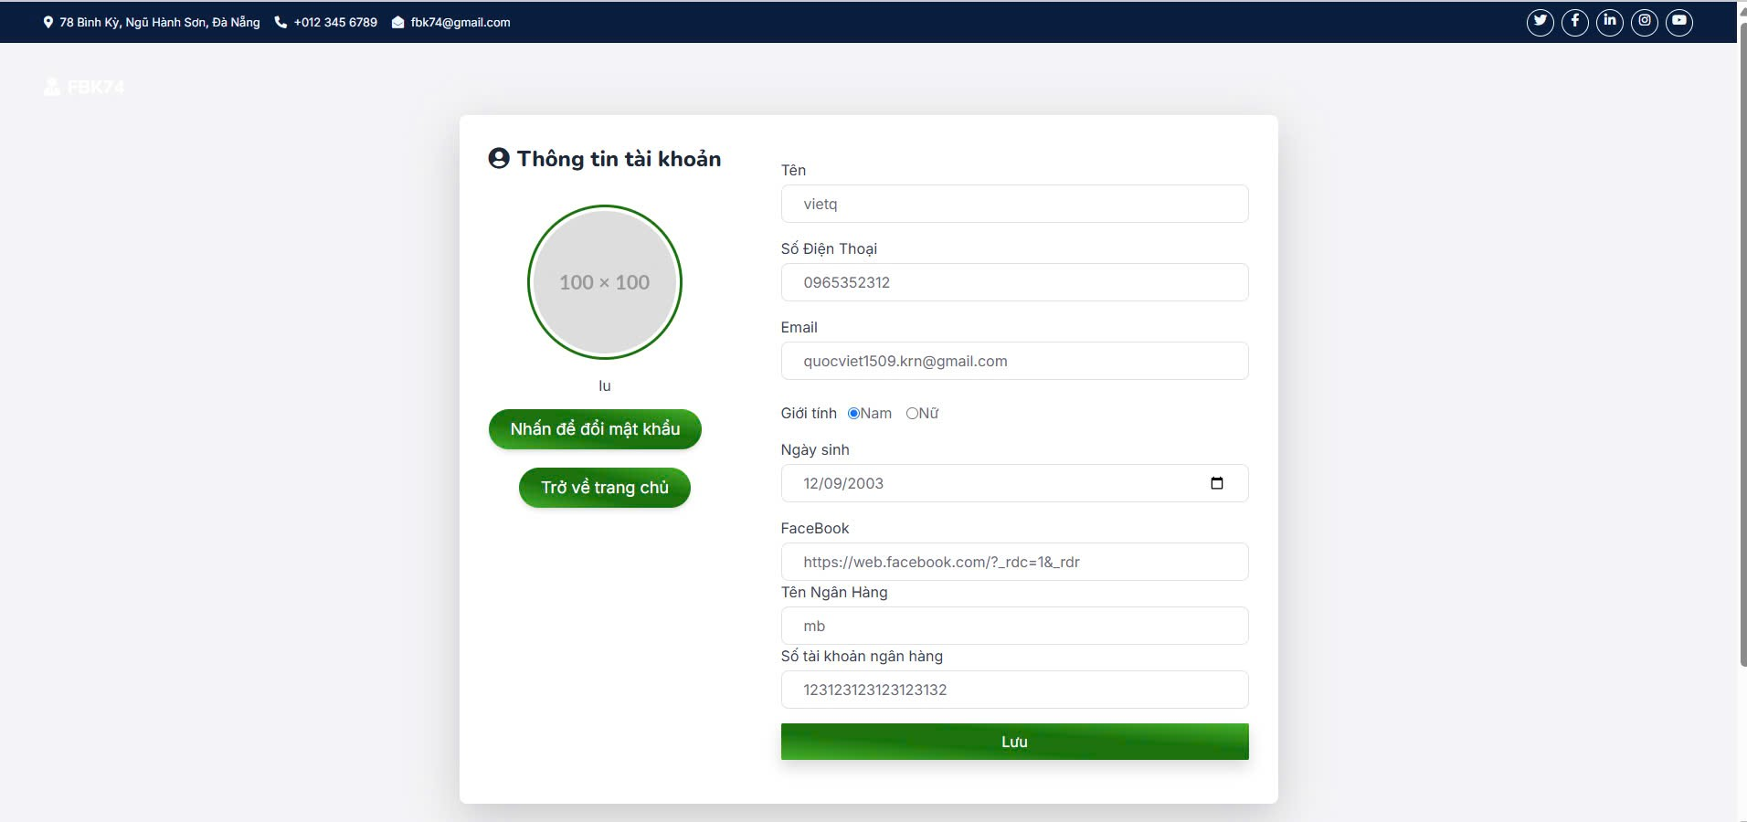

3.3 Change password
This feature allows users to change their password
Steps to follow:
- Access the Homepage while logged into your account.
- Hover over your profile avatar in the top right corner.
- Click on “Tài khoản của tôi” (My Account) to go to the profile page.
- On the profile page, click the “Nhấn để đổi mật khẩu” (Click to Change Password) button.


- Enter the required information correctly, then click "Save" to complete the password update.
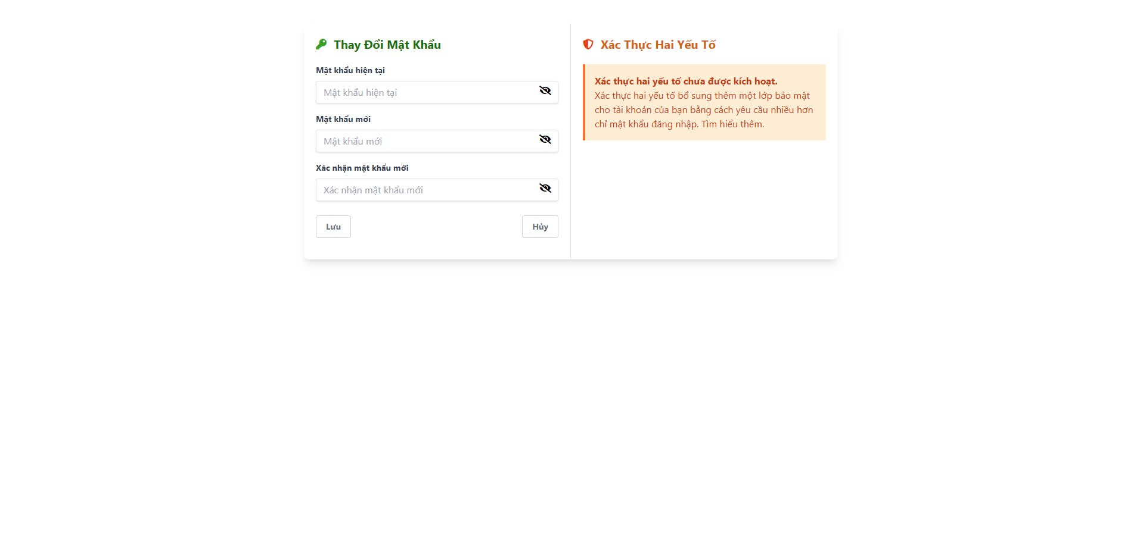
3.4 View Field
This function displays the list of available PickleBall courts for booking on the PickleBall47 website homepage. Steps to follow:
- Open the project with NetBeans.
- Click the "Tìm sân" button on the navigation bar to view the available courts.

3.5 Search Field
This is a function for users to search for field
Steps to follow:
- Access the court booking page while logged into your account.
- Click on the "Ngày" (Date) field and select a date.
- Click on the "Thời gian" (Time) field and choose a time slot.
- Click on the "Loại sân" (Court Type) field and select a court type or leave it as "Tất cả" (All).
- Click the "Tìm kiếm" (Search) button to display available courts.
- Review the available courts and pricing details.
- Click the "Đặt sân" (Book Court) button on the preferred court.
- Click on "Sân đã đặt" (Booked Courts) to view your booked courts.
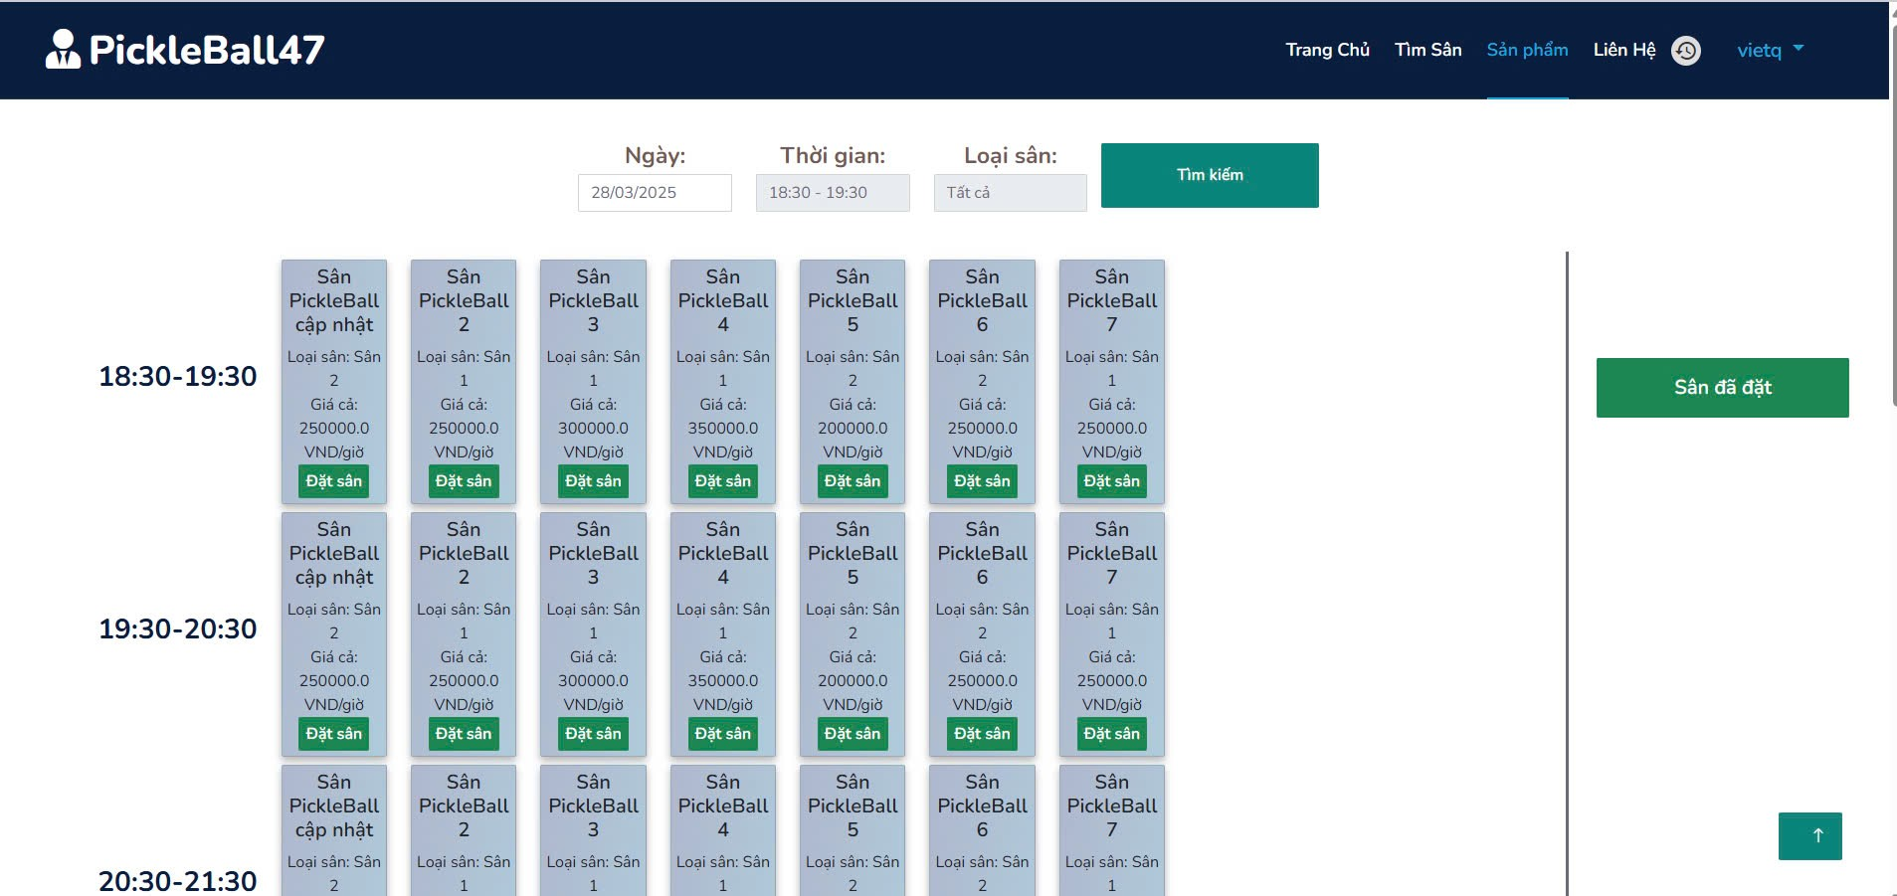

3.6 Booking Field
This function allows users to explore and book available PickleBall courts on the PickleBall47 website.
Steps to follow:
- Log into your account to access the court booking system.
- Select the desired date, time, and court type from the booking interface.
- Click the "Tìm kiếm" button to view available courts.
- Browse through the list of available courts for the selected time slot.
- Click the "Đặt sân" button on your preferred court to proceed with the booking.
- Review booking details, including court type, time, and price.
- Confirm your booking to secure the court for your selected time.
- View booked courts in the "Sân đã đặt" section.


3.7 Cancel Booking
This function allows users to cancel a previously booked PickleBall court on the PickleBall47 website.
Steps to follow:
- Log into your account to access your booking history.
- Navigate to the "Sân đã đặt" (Booked Courts) section to view your current reservations.
- Find the booking you wish to cancel from the list of booked courts.
- Click the "Hủy đặt sân" (Cancel Booking) button next to the selected booking.
- Confirm the cancellation to remove the booking from your list.
- Receive a confirmation message indicating that your court reservation has been successfully canceled.
3.8 View Product Sport
This function displays the list of available PickleBall products for purchase on the PickleBall47 website homepage. Steps to follow:
- Open the project with NetBeans.
- Click the "Sản phẩm" button on the navigation bar to view the product list.


3.9 View Product Detail
This function allows users to browse and view the list of available PickleBall products for purchase on the PickleBall47 website. Steps to follow:
  - Access the product page while logged into your account.
  - Use the search bar to find a specific product or browse the available item
  - Click the "MUA NGAY" (Buy Now) button under the product you want to view.
  - The system will redirect you to the order detail page, displaying:
- Product name, image, and description.
- Price and available stock.
- Key features and specifications.
- Purchase options and shopping cart functionality.
5. Review the details before adding the product to your cart or making a purchase.
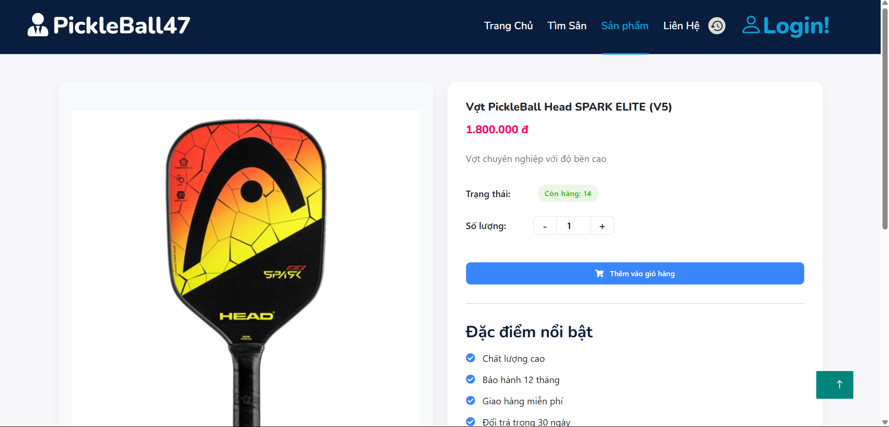

3.10 Order Detail
This function allows users to explore and view the details of their completed or pending orders on the PickleBall47 website.
Steps to follow:
- Log into your account to access your order history.
- Select an order from the list to view its details.
- The order detail page will display:
  - Order number and status.
  - Total price of the order.
  - Purchase date and time.
  - List of purchased items, including:
    - Product name and image.
    - Price and quantity bought.
    - Total cost per item.
    - Action to view more details.
- Review the details to verify your purchase and track your orders.
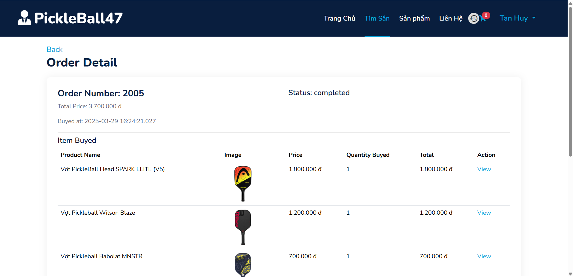

3.11 Order History
This function allows users to explore and view their order history on the PickleBall47 website.
Steps to follow:
- Log into your account to access your order history.
- Use the date filter or status filter to refine the order list.
- Review the list of past orders, which includes:
  - Order number
  - Total price
  - Order status (e.g., completed, pending, canceled)
  - Date and time of order creation
- Click on the "Detail" link next to an order to view more information.
- On the order detail page, you can view:
  - A summary of the order
  - Items purchased and their prices
  - Payment and shipping details
  - Order status updates

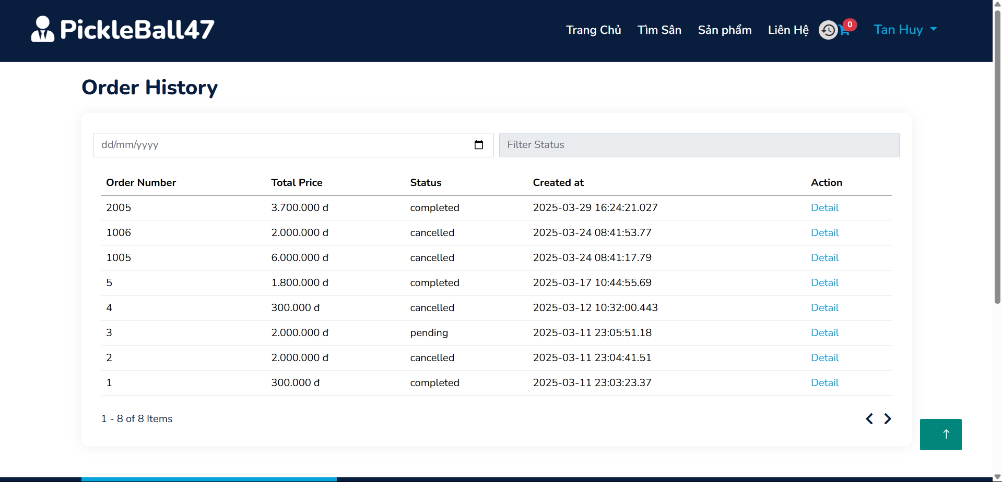

3.12 View Cart
This function allows users to view and manage the products they have added to their shopping cart on the PickleBall47 website.
Steps to follow:
- Log into your account to access your shopping cart.
- Navigate to the cart page to review your selected products.
- The cart page will display:
  - Product name, image, and price.
  - Quantity adjustment options (+/-).
  - Available stock for each item.
  - Option to remove items from the cart.
- Review the total price and ensure all selected products are correct.
- Proceed to checkout by clicking the "Thanh Toán" button.
- Continue shopping if you want to add more items before completing the purchase.

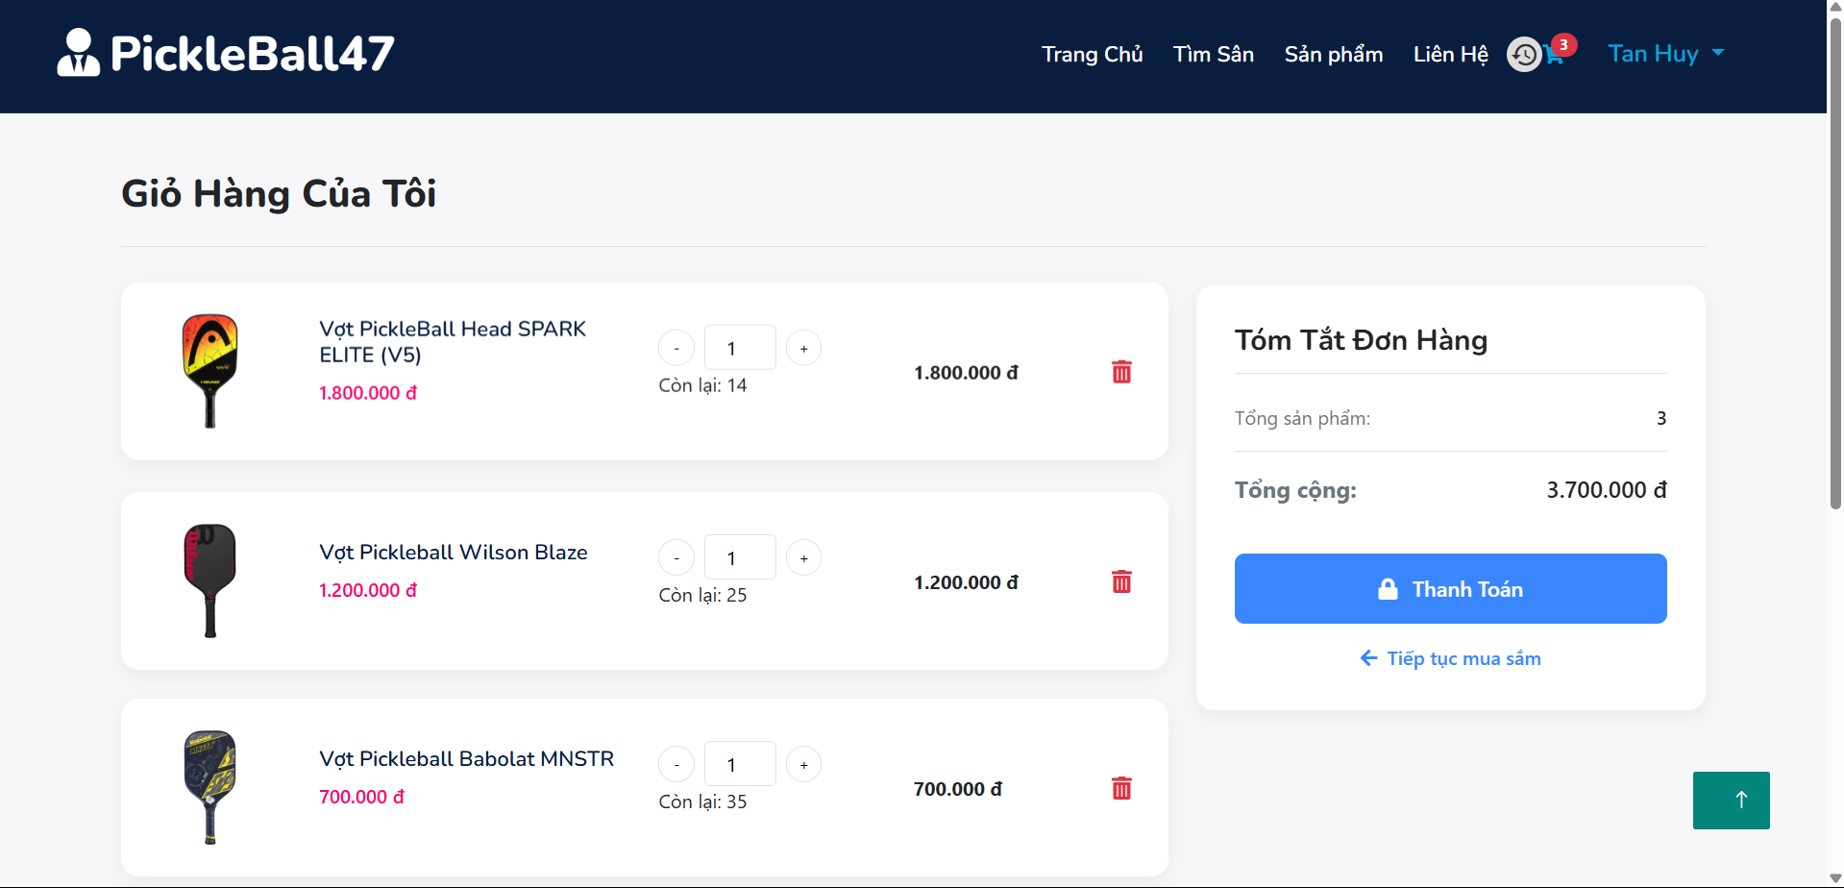

3.13 Product Payment
This function allows users to complete the payment process for their selected PickleBall products on the PickleBall47 website.
Steps to follow:
- Log into your account and proceed to the cart page.
- Review your order, including product details, quantity, and total cost.
- Click on the "Thanh Toán" button in the cart to proceed to checkout.
- Choose a payment method (e.g., VNPay).
- Confirm your payment details before finalizing the transaction.
- Click on the "Đặt Hàng" button to complete your purchase.
- Receive an order confirmation with payment and delivery details.
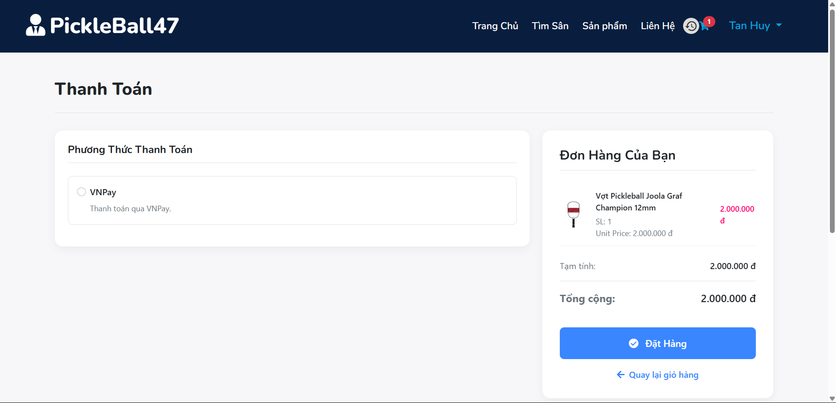

4 . User Manual Guide for Admin
4.1 Create User
This function allows administrators to create a new user account on the PickleBall47 platform.
Steps to follow:
- Log into your admin account to access the user management dashboard.
- Navigate to the "Quản lý người dùng" (User Management) section in the sidebar.
- Click the "Thêm người dùng" (Add User) button to open the user creation form.
- Fill in the required information, including:
- Full name
- Username
- Email address
- Role (Customer, Staff, or Admin)
- Password
- Set additional preferences, such as account status (active or blocked).
- Click the "Lưu" (Save) button to create the new user.
- Confirm the creation and verify that the new user appears in the user list.

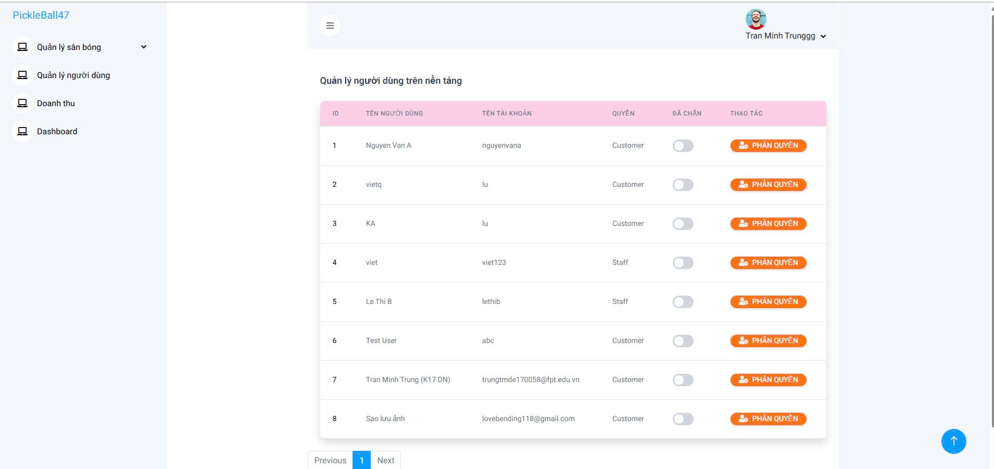

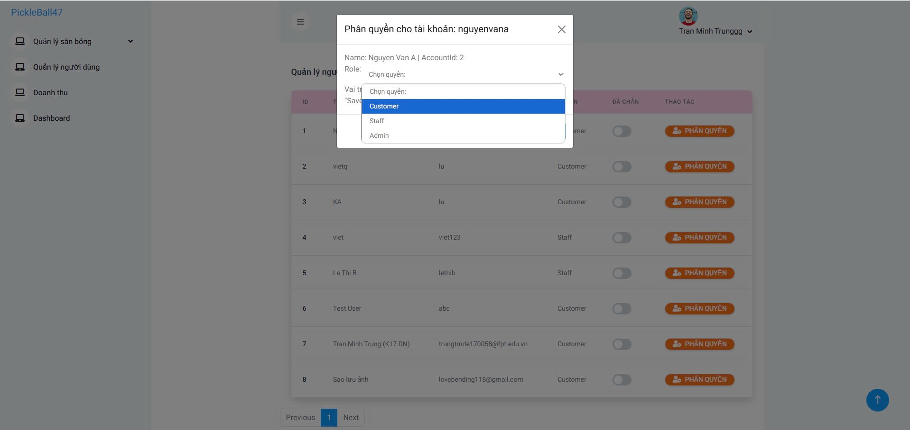

4.2 Ban User
This function allows administrators to temporarily or permanently ban a user on the PickleBall47 platform.
Steps to follow:
- Log into your admin account and navigate to the "Quản lý người dùng" (User Management) section.
- Find the user you want to ban in the user list.
- Toggle the "ĐÃ CHẶN" (Blocked) switch next to the user's name.
- Confirm the action when prompted to ensure the user is banned.
- The user's access to the platform will be restricted, and they will not be able to log in.
- If needed, you can unblock the user later by toggling the switch back.
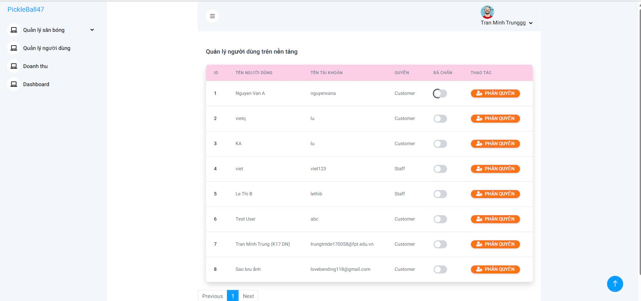

4.3 Revenue Management
This feature helps manage and track revenue on the PickleBall47 platform.
Steps to Follow:
- Log in as an administrator and select the "Revenue" section from the left-hand menu.
- View revenue overview, including:
  - Total revenue by day, week, month, and year.
  - Revenue by specific services/products.
  - Visual revenue charts.
- Filter revenue by time period by selecting the desired date range.
- Export revenue reports if needed (depending on system capabilities).
- Analyze and make decisions, such as optimizing services or adjusting business strategies based on revenue data.
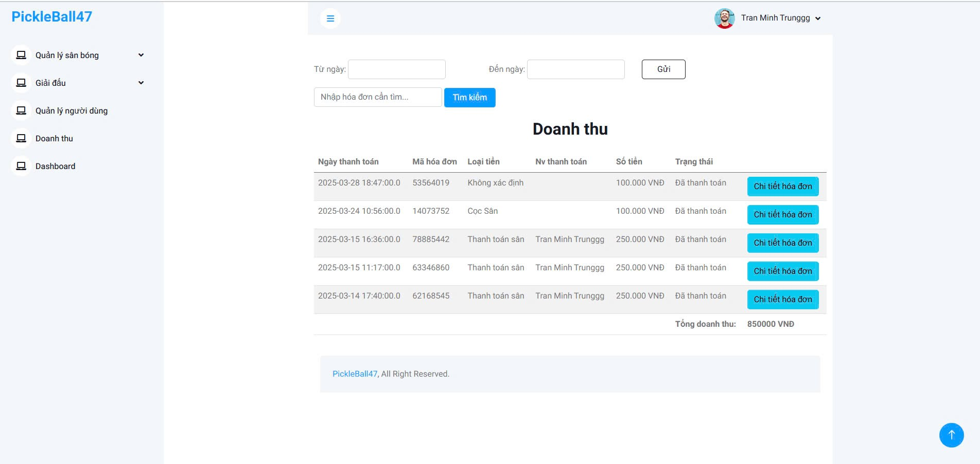

4.4 Invoice Details
This feature allows administrators to view detailed information about each invoice on the PickleBall47 platform.
Steps to Follow:
- Navigate to the "Revenue" section from the left-hand menu.
- Click on the "Invoice Details" button corresponding to the invoice you want to review.
- The invoice details page displays:
  - Invoice ID
  - Payment Date & Time
  - Payment Type (e.g., court deposit, court payment, etc.)
  - Customer Name (if available)
  - Amount Paid
  - Payment Status (Paid/Unpaid)
  - Additional Notes or Payment Method
- If needed, export or print the invoice for record-keeping.


4.5 Approving Orders
This feature allows administrators to approve or confirm customer orders on the PickleBall47 platform.
Steps to follow:
- Access the "Revenue" section from the left menu.
- Select the order to be approved from the invoice list.
- Review the order details, including:
  - Payment time
  - Payer’s name
  - Total invoice amount
  - Amount already deducted (if a deposit was made)
  - Total amount to be paid
- Click the "Confirm" button to approve the order.
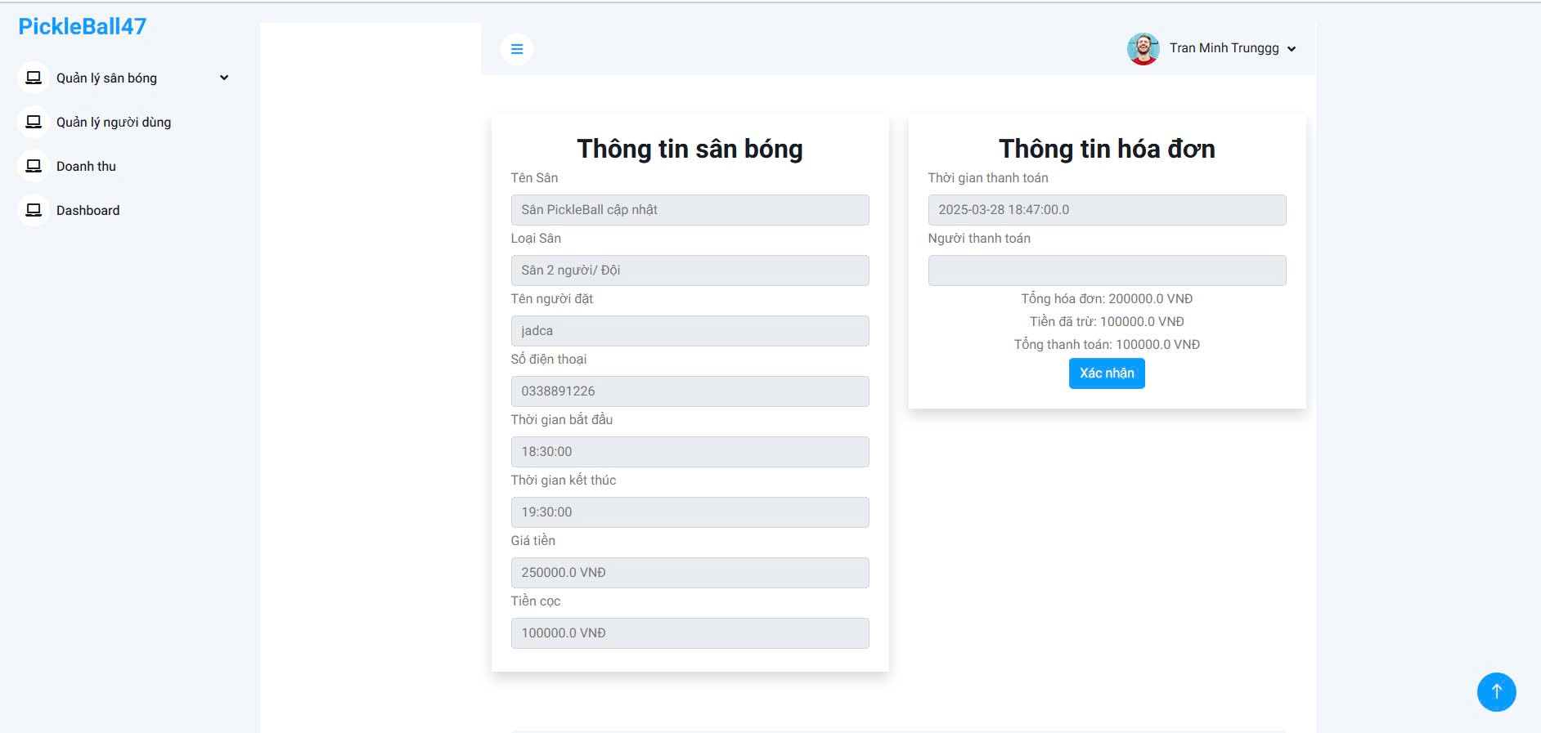

4.6 Searching for Orders
This feature allows administrators to quickly find specific invoices on the PickleBall47 platform based on various criteria.
Steps to follow:
- Access the "Revenue" section from the left menu.
- Use the search filters at the top of the page:
  - By date range: Enter a start and end date.
  - By invoice ID: Enter the invoice number in the search box.
- Click the "Search" button to display matching results.
- The system will list all invoices that match the entered criteria.
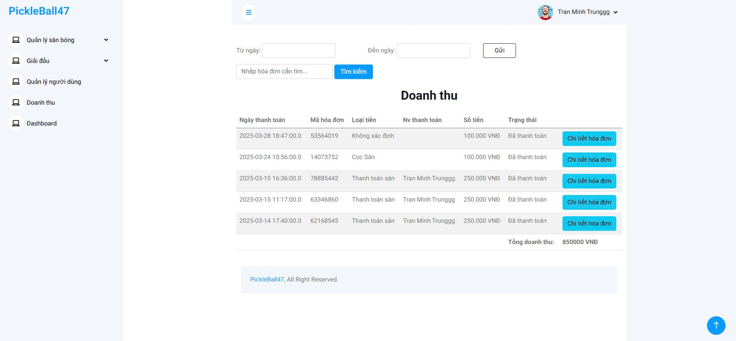

4.7 Create Court
This feature allows administrators to add new pickleball courts to the PickleBall47 platform efficiently.
Steps to follow:
- Access the "Manage Courts" section from the left menu.
- Click on the "Add New Court" button.
- Fill in the required fields:
  - Court Name: Enter a name for the court.
  - Court Type: Select the type of court
  - Price: Enter the price in VND.
  - Available Time Slots: Specify the time range when the court is available for booking.
- Click the "Save" button to finalize the creation of the new court.
- The system will display a confirmation message and list the newly added court in the court information section.
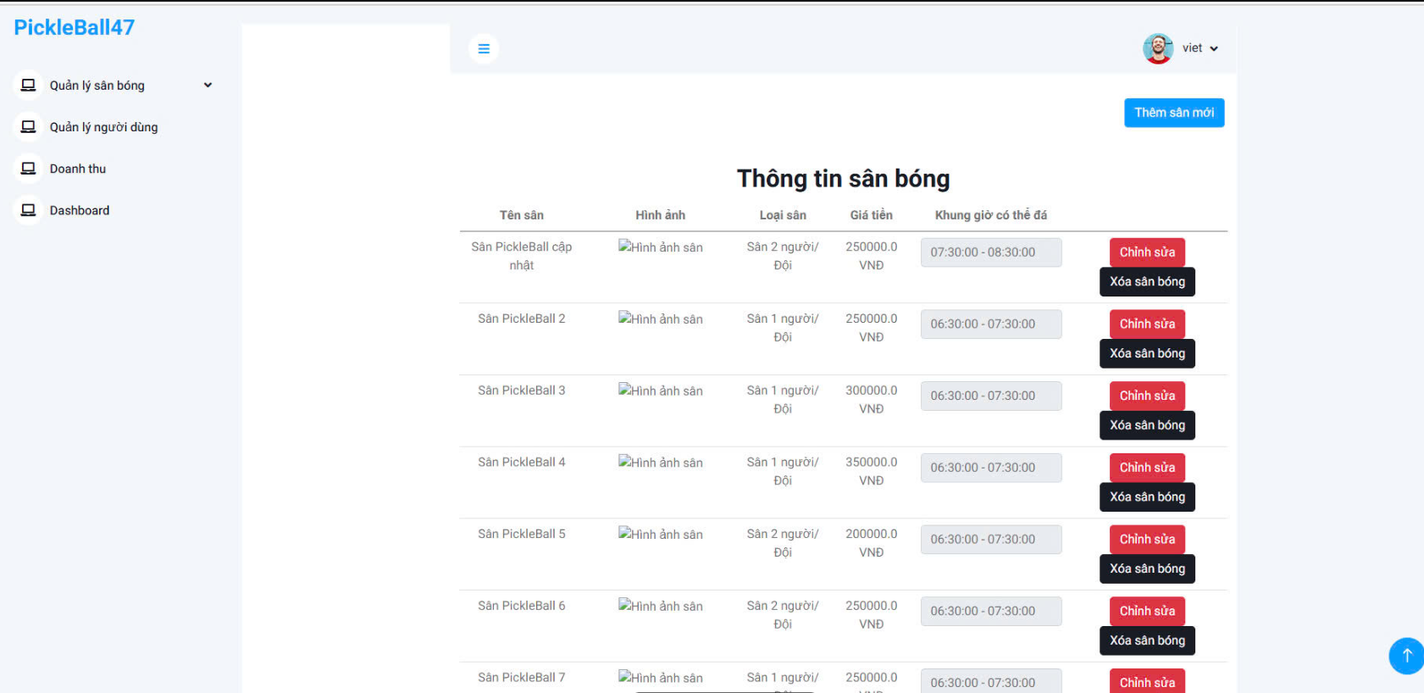

4.8 Delete Court
This feature allows administrators to remove existing pickleball courts from the PickleBall47 platform.
Steps to follow:
- Access the "Manage Courts" section from the left menu.
- Locate the court you wish to delete from the list.
- Click on the "Delete Court" button next to the relevant court.
- A confirmation dialog will appear asking if you are sure you want to delete the court.
- Click "Confirm" to proceed with the deletion or "Cancel" to abort the action.
- The system will display a notification confirming the successful deletion of the court, and it will no longer appear in the court information section.
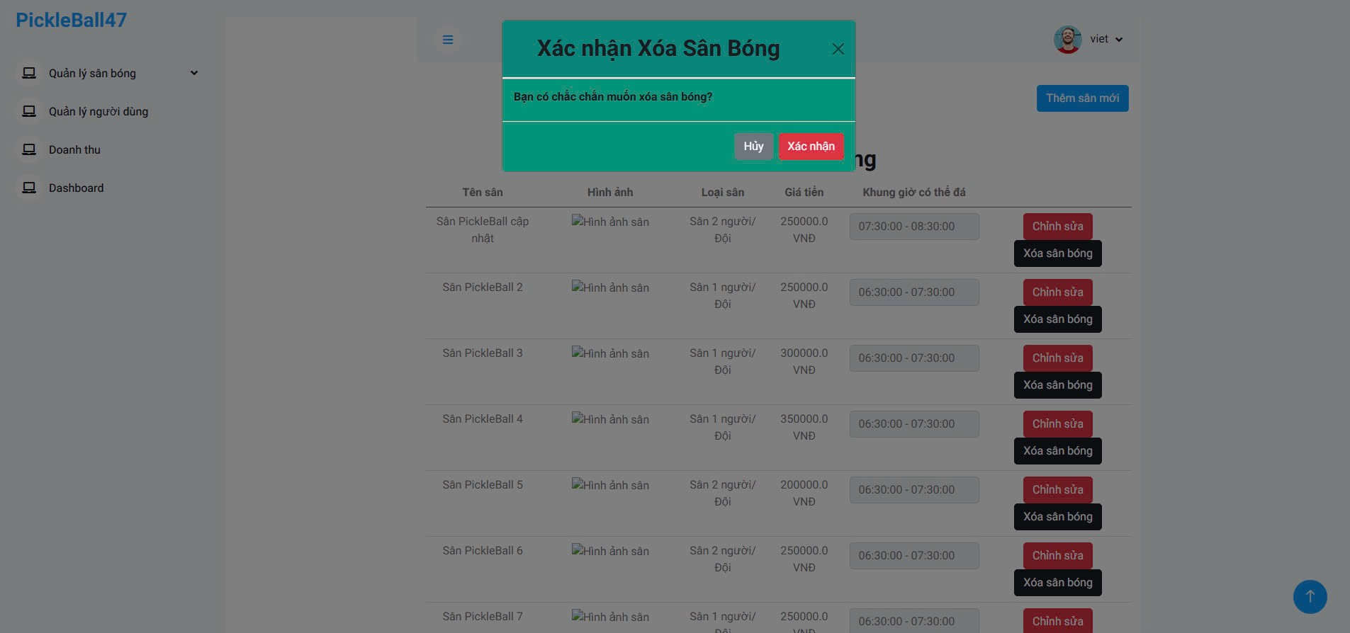

4.9 Edit Court
This feature allows administrators to modify the details of existing pickleball courts on the PickleBall47 platform.
Steps to follow:
- Access the "Manage Courts" section from the left menu.
- Find the court you wish to edit from the list.
- Click on the "Edit Court" button next to the relevant court.
- Update the necessary fields:
  - Court Name: Modify the name of the court if needed.
  - Court Type: Change the court type if applicable.
  - Price: Adjust the price in VND as necessary.
  - Available Time Slots: Update the time range for the court's availability.
- Click the "Save" button to apply the changes.
- The system will display a notification confirming that the court details have been successfully updated, and the changes will be reflected in the court information section.

4.10 Confirm Court Booking
This feature allows administrators to confirm booking requests made by users on the PickleBall47 platform.
Steps to follow:
- Access the "Booking Requests" section from the left menu.
- Review the list of pending booking requests displayed on the page.
- Click the "Confirm" button next to the booking request you wish to approve.
- A confirmation dialog will appear with the message:
  - "Bạn có chắc chắn muốn xác nhận đơn đặt?" (Are you sure you want to confirm this booking?)
- Click "Xác nhận" (Confirm) to proceed with the booking confirmation or "Hủy" (Cancel) if you do not wish to confirm the request.
- Once confirmed, the system will display a notification indicating that the booking has been successfully confirmed, and the status of the booking request will be updated in the system.
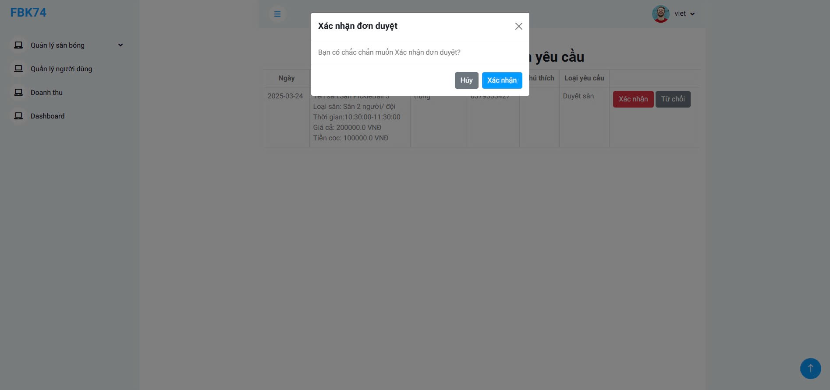

4.11 Cancel Court Booking

This feature allows administrators to cancel an existing court booking on the PickleBall47 platform.
Steps to follow:
- Access the "Booking Requests" section from the left menu.
- Review the list of booking requests that are currently pending or confirmed.
- Click the "Cancel" button next to the booking request you wish to cancel.
- A confirmation dialog will appear with the message:
  - "Bạn có chắc chắn muốn hoàn lại tiền đơn đặt?" (Are you sure you want to cancel this booking?)
- Click "Hoàn cục" (Confirm) to proceed with the cancellation or "Hủy" (Cancel) if you do not want to proceed.
- Once confirmed, the system will display a notification indicating that the booking has been successfully canceled, and the status of the booking request will be updated in the system.
